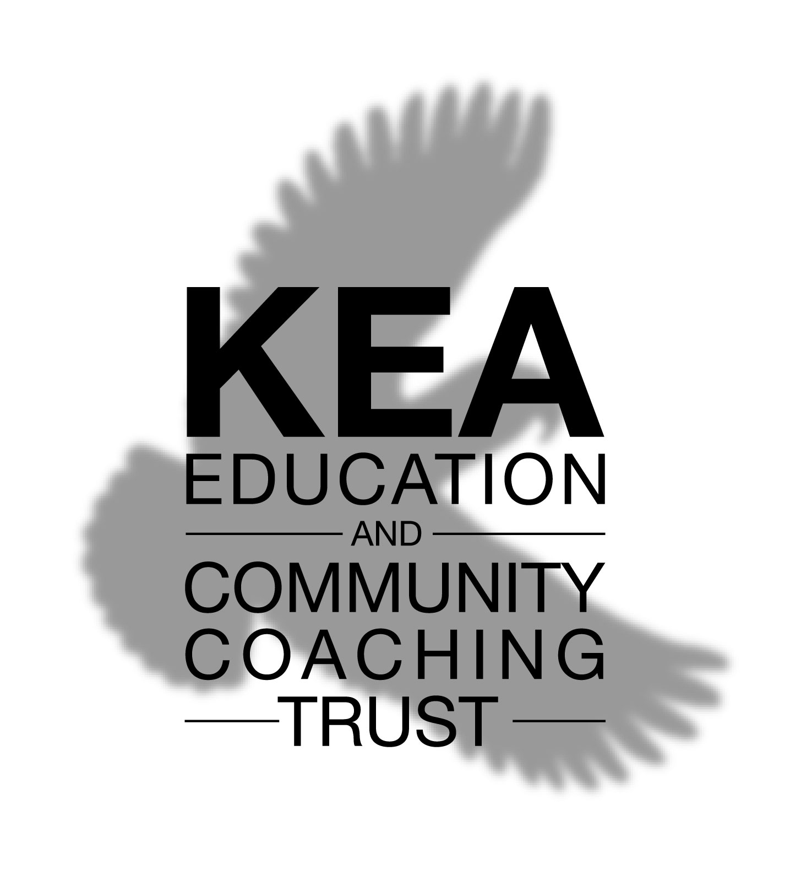

Memorandum of Understanding between

KECCT and XXXXXX School

Dated

Xx xxxx 2008

Prepared By:
Xxxx xxxxxxx
KECCT

- Background
Discussion | Following discussion with xxxx, it was agreed that this coaching programme would be progressed over the period xxxx to xxxx and include the following:  - Coaching of X managers/teachers for 6 sessions each  - Delivery of a 1 day coaching skills workshop for x staff  - Supply of 1 coaching skills activity for teachers to deliver

- Programme Objectives
Programme Objectives | The desired outcomes of the programme are:  - Outcome 1  - Outcome 2  - Outcome 3

How this will be achieved | - A series of six 1:1 coaching sessions commencing Date. Each session to last 1 hour and to take place at a frequency agreed between the coach and client, but completied within a period of 3 months.  - Coaching assignments to work on between sessions (e.g. readings, self-observation, practice)  - Attending a 1 day workshop covering the key skills of coach-like behavior to be held at location on date.

- Coaching Programme
The primary aim of the coaching sessions is to expose the managers/teachers in the school to what it is like to be coached and what can be achieved through using a coach approach. This prepares the manager/teacher for participation in the coaching skills workshop, allowing them to bring to mind examples of the skills as they were applied to them during their coaching.
The reason for chosing 6 sessions over a 3 month period is that this is typically viewed as the minimum level to see the benefits of coaching. While the coaching sessions are essential elements in the programme most of the learning happens between the sessions, hence the need for a significant time period..
Your Output
Events

Coaching Session 1 – In Take
- This session is a guided discussion looking at values
Duration 1.0 Hour

Coaching Session 2 – 5
Duration 1.0 Hours

Coaching Session 6 - Completion
Duration 1.0 Hours

- Commitment expected from the School and Staff
For the coaching programme to be successful there are certain commitments that are needed from the School and those being coached. These are:
Availability – the Trust coaches will endeavour to fit in with the teaching programme and hold coaching sessions at convenient times. It is expected that once a time is agreed the manager/teacher will make every effort to keep the appointment.
Motivation & Commitment – it is expected that the manager/teacher will be motivated and committed to taking action on any determined personal & professional goals. It is further expected that the teacher/manager will be committed to following through on agreed actions consistently, and realise that anything less than full participation will not lead to success.
Where a coaching skills workshop is arranged for the school, suitable facilities will be provided and the principal will encourage maximum attendance by the invited staff

5. Kea Education and Community Coaching Trust
Overview |  | Mission  To have a positive impact on the Christchurch community by supporting:  - schools to operate more effectively, and develop in their students the ability to act in a coach like manner when appropriate  - other community agencies through the provision of coaching services  Objectives  - To promote the benefits of coaching and coach like behaviour in schools  - To foster coach like behaviour in school management and teachers  - To provide school management and teachers with access to quality coaching, enabling them to experience and demonstrate coach-like behaviour to students.  - To provide community agencies with coaching services.  - To develop resources to support the trust in executing its objectives
The Trust Coaches |  | All KECCT coaches must meet minimum requirements in terms of formal training and experience:  - 60hrs of formal coaching training approved by ICF or equivalent organisation  - 40 hrs of doumented client coaching  In addition coaches who are not credentialed by the International Coaching Federation (ICF) or a similar professional body have to pass a review by a credentialed coach and receive supervision while working with the Trust.  The Trust has produced a set of ethetical standards, based on the ICF’s, to which all Trust coaches must adhere.
6. About Coaching

Coaching Sound bites | “Coaching is not about learning the right way, but is about helping lead an individual to find their best way.”  “Our performance equals our potential minus our internal interference, of which lack of self-belief is the greatest. Coaching does not therefore seek to add anything but rather to remove any internal obstacles to performance, learning and enjoyment.”  “Coaching is a means of helping people to uncover and bring out the best in themselves, their pupils and the teams they work with.”  “It is a collaborative process through a one-on-one relationship to expand capability, build confidence, realise potential and achieve sustainable change.”

