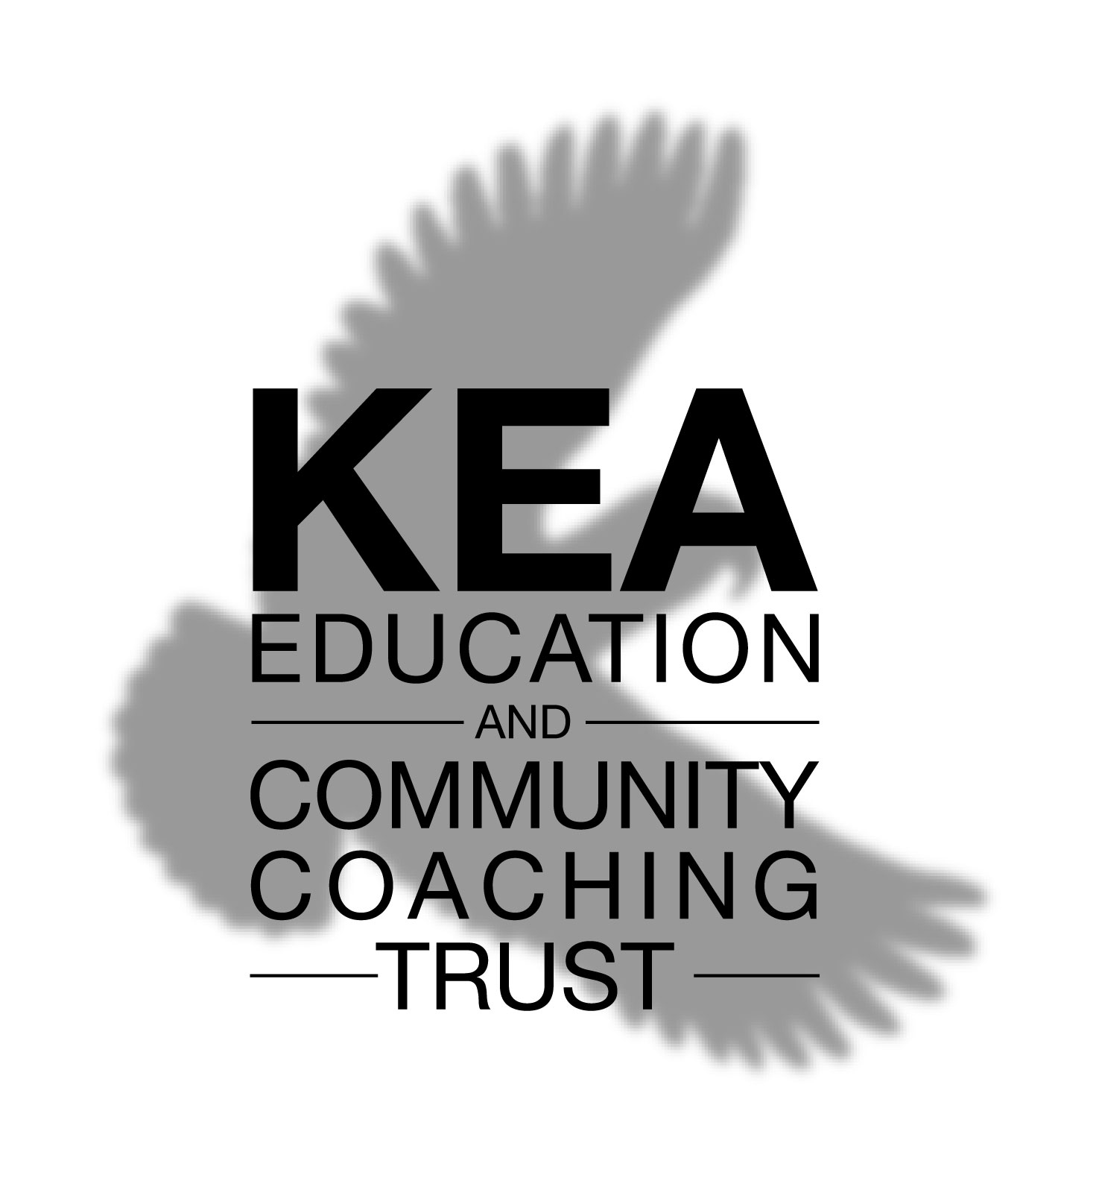
KECCT Expression of Interest – Not for profit NGO

The Trust has a limited number of resources so it is likely that the Trustees will need to make an assessment as to which NGOs will benefit most from the coaching. The following information is required to assist in that assessment and to follow up with the NGO.

Name of NGO:______________________________________

Address: _____________________________________________________________

_____________________________________________________________

Point of Contact: _______________________

Phone: ________________ E-mail: ____________

Please attach any information that will help the Trustees gaining a better understanding of the mission and purposes of your organisation.

The NGO is interested in the following (tick those that apply):

Coaching of management/leaders □

- Name _____________________ Role ____________________

- Name _____________________ Role ____________________

- Name______________________ Role ____________________

Coaching Skills Workshop for managers/leaders □

- Number of places __________

Coaching of Client(s) □ 1:1 Coaching □ Group Coaching □

Please attach a description of the type of clients that the NGO would want coached. If coaching in groups the size of group.

Signed: ____________________________ Date: __________________

Return to: 16 McMahon Drive, Halswell, Christchurch, 8025

